

API SECURITY RISK ANALYSIS REPORT

Divya Sri K

June 09, 2026

—

Cyber Security Internship

—

Future Interns

TABLE OF CONTENTS
1 | Executive Summary | 3
2 | Methodology | 3
3 | API Overview | 4
4 | End point Analysis | 4
5 | Security Findings | 9
6 | Positive Security Controls Observed | 10
7 | Risk Assessment Summary | 11
8 | Remediation Recommendations | 12
9 | Key Takeaways | 12
10 | Conclusion | 12
11 | References | 13

1.EXECUTIVE SUMMARY:
- This report presents an API Security Risk Analysis conducted on the JSONPlaceholder public API. The assessment was performed to evaluate common API security risks, review endpoint accessibility, inspect response data, and assess the implementation of basic security controls.

- Five API endpoints were analyzed using Postman. The review identified several security concerns, including unauthenticated access to resources, excessive data exposure, predictable resource identifiers, and technology disclosure through response headers. Additionally, positive security controls such as rate limiting, Cloudflare protection, and secure response headers were observed.

- Although JSONPlaceholder is intentionally designed as a testing platform and does not represent a production environment, the assessment demonstrates common API security considerations that organizations should address when designing and deploying APIs.

- The findings have been classified based on their potential business impact and are accompanied by practical remediation recommendations aligned with secure API development practices.

2.METHODOLOGY:
- The API Security Risk Analysis was conducted using a structured assessment approach focused on identifying common security weaknesses in publicly accessible APIs.
- The assessment included the following activities:
  - Review of API documentation and publicly available endpoints.
  - Testing of API endpoints using Postman.
  - Inspection of HTTP requests and responses.
  - Analysis of response headers and security-related configurations.
  - Identification of potential security risks and exposures.
  - Classification of findings based on severity and business impact.
  - Development of remediation recommendations based on secure API development practices.
- Tools Used:
  - Postman
  - Web Browser Developer Tools
  - JSONPlaceholder Public API
  - Microsoft Word
  - GitHub
- Assessment Scope:
  - The assessment was limited to read-only testing of publicly accessible API endpoints. No exploitation attempts, authentication bypasses, denial-of-service testing, or unauthorized activities were performed.

3.API OVERVIEW:
- API Name: JSONPlaceholder
- API URL: https://jsonplaceholder.typicode.com
- JSONPlaceholder is a free online REST API designed for testing and prototyping applications. It provides sample resources including users, posts, comments, albums, photos, and todos.
- The platform is commonly used by developers for learning API integration, testing HTTP requests, and building proof-of-concept applications.
- For this assessment, the following endpoints were reviewed:
    - GET /users
    - GET /users/1
    - GET /posts
    - GET /posts/1
    - GET /comments
- The objective of the assessment was to evaluate how these endpoints expose data, identify potential security concerns, and review the implementation of security controls visible through API responses.

4.ENDPOINT ANALYSIS:

4.1. ENDPOINT 1:

Request URL: https://jsonplaceholder.typicode.com/users

Observation: The API returns:
- Name
- Username
- Email
- Address
- Geo-location data
- Company information
without requiring authentication.

Risk: Excessive Data Exposure

Severity: Medium

Business Impact: Sensitive user information may be exposed to unauthorized individuals, increasing privacy and reconnaissance risks.

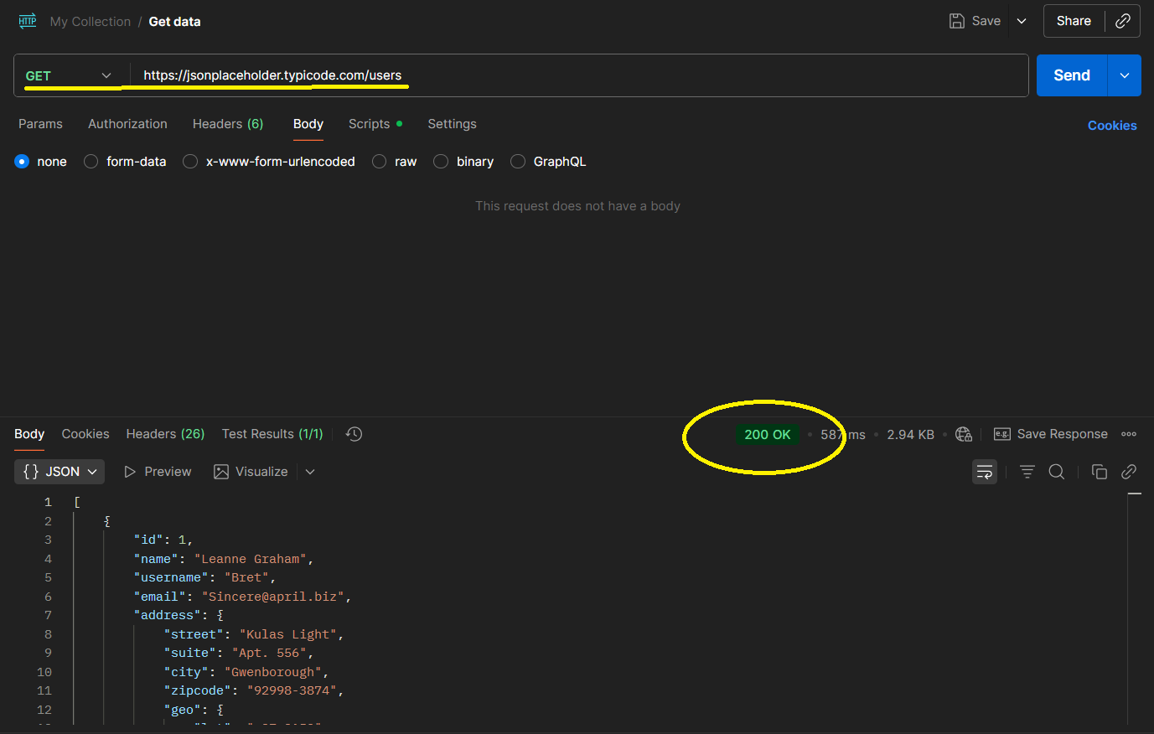
Figure 4.1: GET/users Request in Postman Screenshot

Recommendation: Return only necessary fields and implement authentication controls where appropriate.

4.2. ENDPOINT 2:

Request URL: https://jsonplaceholder.typicode.com/users/1

Observation: Individual user records can be accessed directly without authentication.

Risk: Unauthenticated Access to User Information

Severity: Medium

Business Impact: Unauthorized users may retrieve user information without verification.

Recommendation: Require authentication and authorization checks before returning user data.
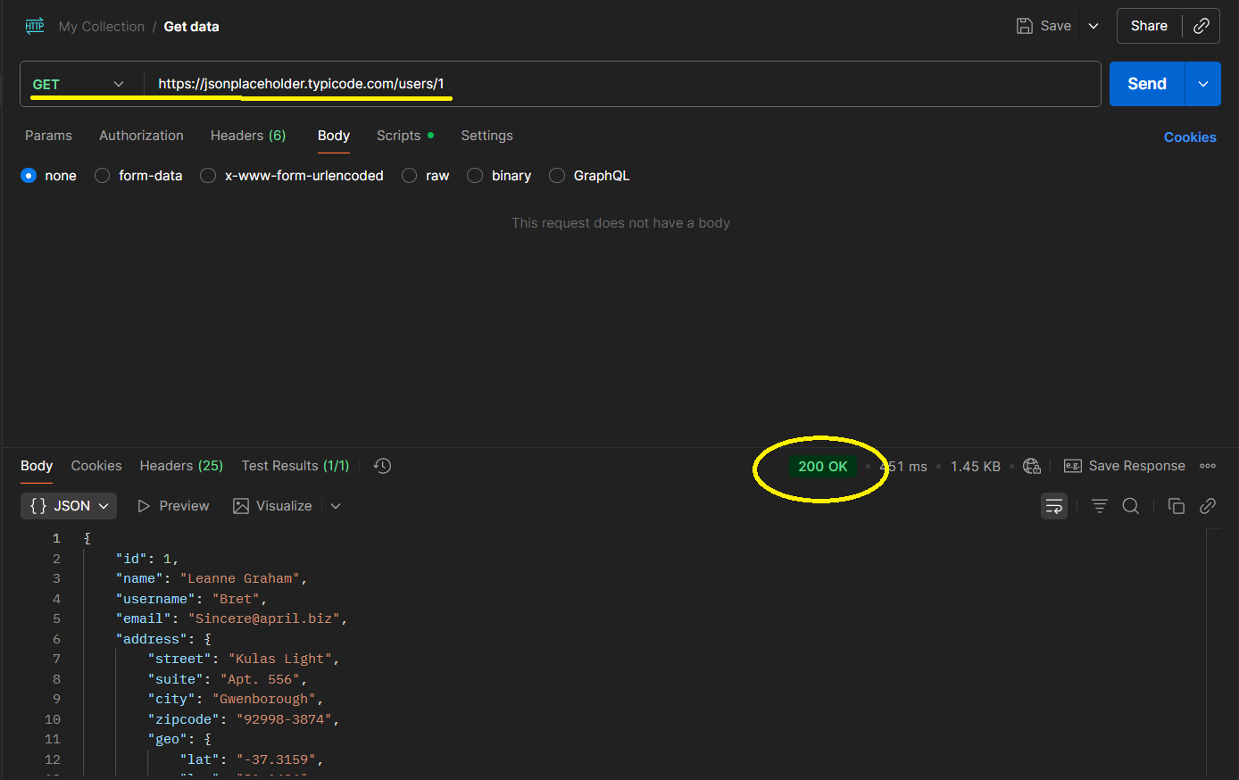
Figure 4.2: GET/users/1 Request in Postman Screenshot

4.3. ENDPOINT 3:

Request URL: https://jsonplaceholder.typicode.com/posts

Observation: The endpoint allows unrestricted access to all post records.

Risk: Missing Authentication Controls

Severity: Low

Business Impact: Public access may not be appropriate in production environments and could expose business data.

Recommendation: Apply access controls according to business requirements.

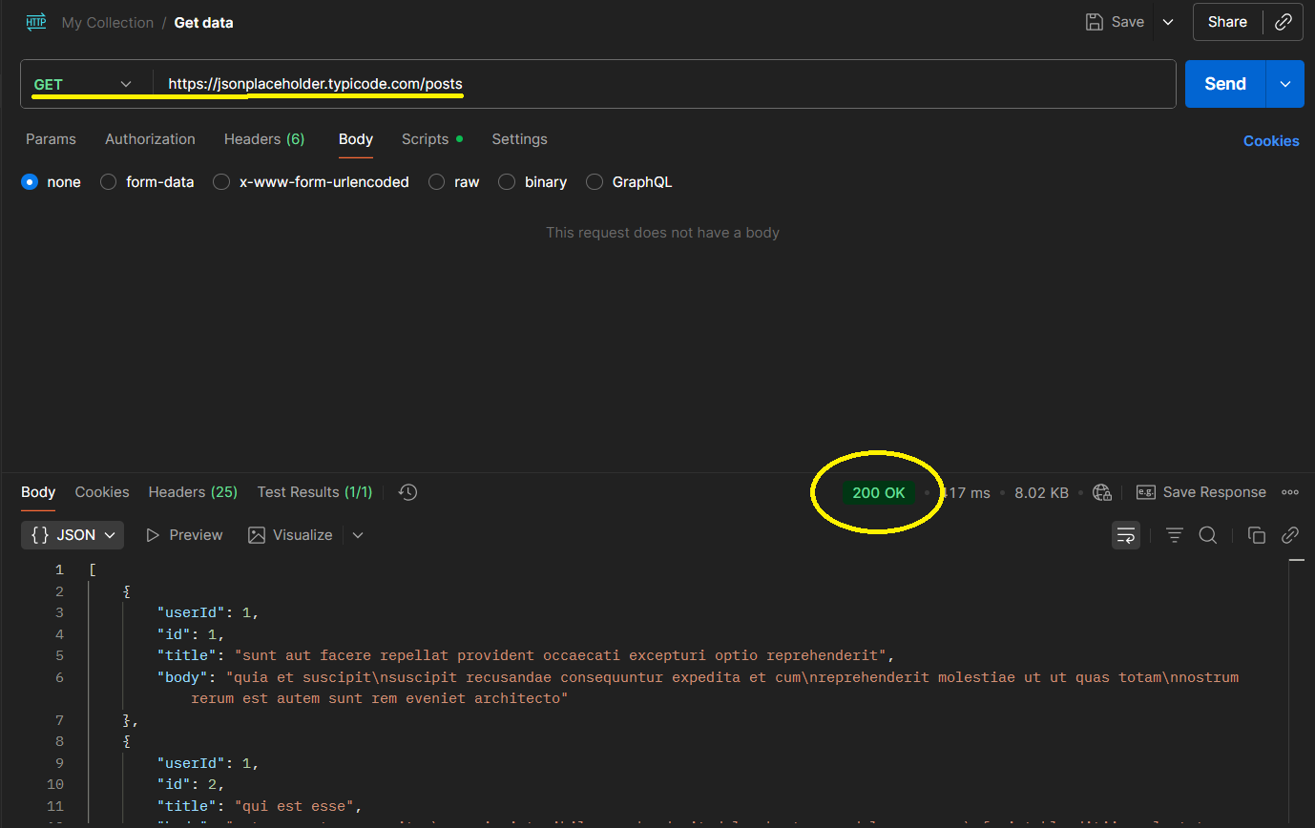
Figure 4.3: GET/posts Request in Postman Screenshot

4.4. ENDPOINT 4:

Request URL: https://jsonplaceholder.typicode.com/posts/1

Observation: Specific records can be queried directly through predictable identifiers.

Risk: Potential Insecure Direct Object Reference (IDOR) Risk

Severity: Low

Business Impact: If sensitive records existed, predictable identifiers could allow unauthorized access.

Recommendation: Implement authorization checks and avoid exposing sensitive resources through predictable IDs.

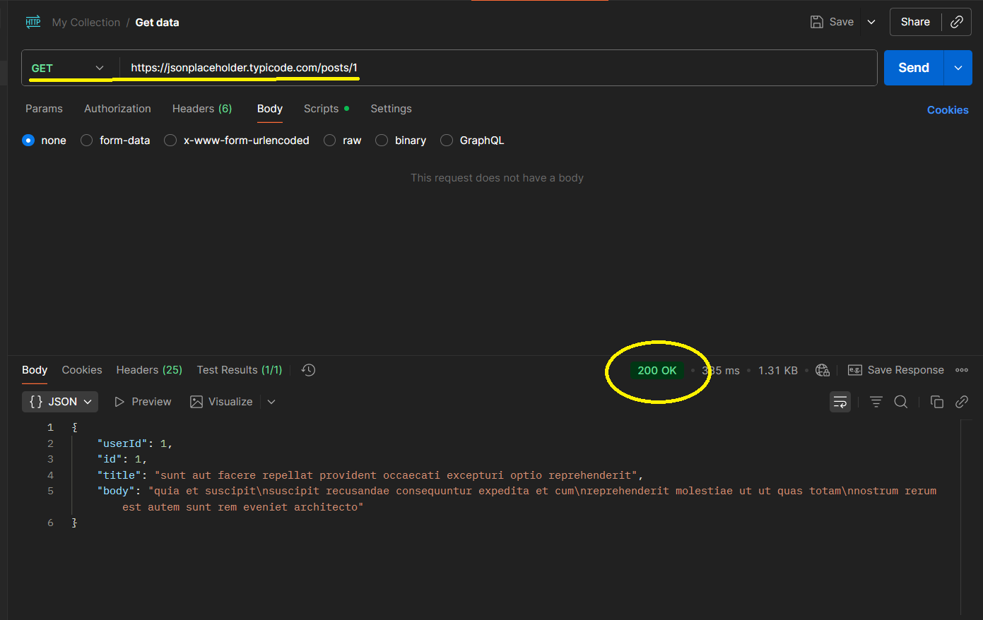
Figure 4.4: GET/posts/1 Request in Postman Screenshot

4.5. ENDPOINT 5:

Request URL: https://jsonplaceholder.typicode.com/comments

Observation: Large volumes of data are returned without authentication.

Risk: Large Data Exposure Through Public Endpoint

Severity: Medium

Business Impact: Attackers could automate requests to harvest data or consume server resources.

Recommendation: Limit bulk data exposure through pagination, filtering, and access controls. Continue monitoring API usage through existing rate-limiting mechanisms.

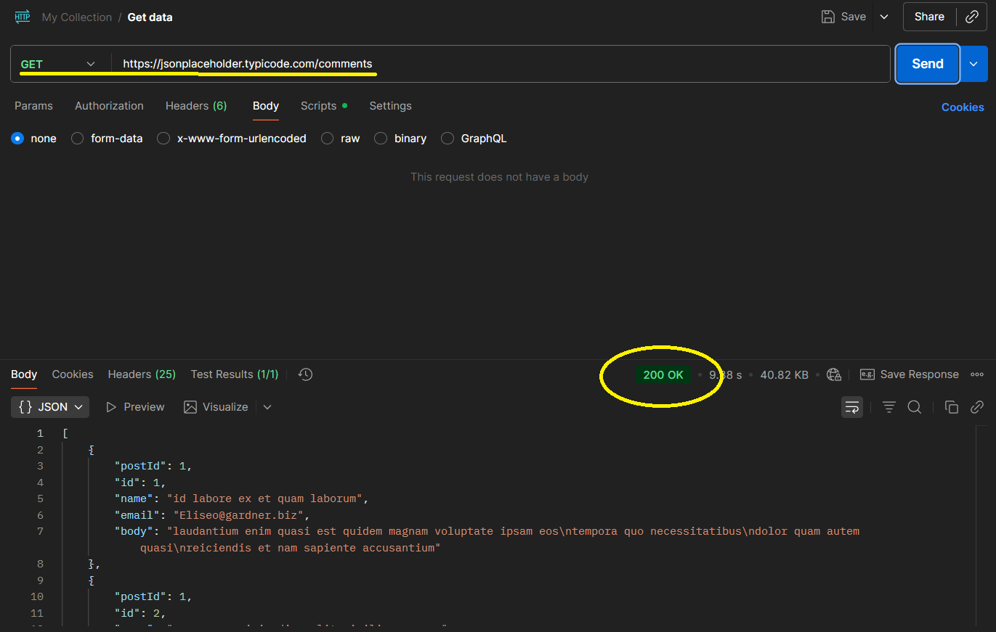
Figure 4.5: GET/comments Request in Postman Screenshot

5. SECURITY FINDINGS:

5.1. MISSING AUTHENTICATION CONTROLS:

Description: Several endpoints were accessible without authentication, allowing any user to retrieve data.

Affected Endpoints:
- GET /users
- GET /users/1
- GET /posts
- GET /posts/1
- GET /comments

Severity: Medium

Business Impact: Unauthorized users may gain access to information that should be restricted to authenticated users.

5.2. EXCESSIVE DATA EXPOSURE:

Description: The /users endpoint exposes user names, email addresses, company information, physical addresses, and geographical coordinates.

Severity: Medium

Business Impact: Excessive exposure of user information increases privacy risks and provides valuable information for reconnaissance activities.

5.3. POTENTIAL ENUMERATION RISK:

Description: Resources can be accessed using predictable numeric identifiers such as /users/1 and /posts/1.

Severity: Medium

Business Impact: Attackers may attempt to enumerate records and collect information at scale.

5.4. TECHNOLOGY DISCLOSURE:

Description: Response headers reveal backend technologies including Express, Heroku Router, and Cloudflare.

Evidence:
X-Powered-By: Express
Via: heroku-router
Server: cloudflare

Severity: Low

Business Impact: Technology disclosure may help attackers identify technologies used by the application.

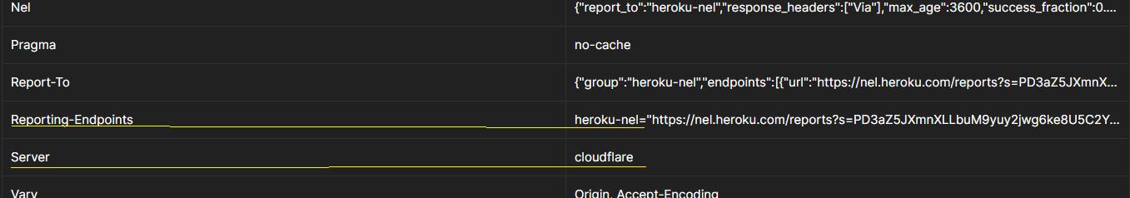
Figure 5.1: Request Headers Screenshot

6. POSITIVE SECURITY CONTROLS OBSERVED:

6.1. RATE LIMITING ENABLED:

Evidence:
X-RateLimit-Limit: 1 000
X-RateLimit-Remaining: 730

Assessment: The API implements request-limiting controls that help prevent abuse.
6.2. SECURITY HEADER PRESENT:

Evidence:
X-Content-Type-Options: nosniff

Assessment: This header improves browser security by preventing MIME-type sniffing.

6.3. CLOUDFLARE PROTECTION:
Evidence:
Server: cloudflare
CF-Cache-Status: HIT

Assessment: Cloudflare provides performance improvements and protection against common web threats.

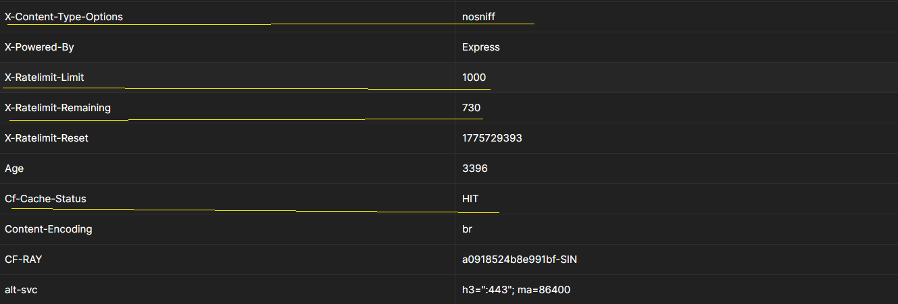
Figure 6.1: Request Headers Screenshot

7. RISK ASSESSMENT SUMMARY:
Finding | Severity
Missing Authentication Controls | Medium
Excessive Data Exposure | Medium
Potential Enumeration Risk | Medium
Technology Disclosure | Low
Rate Limiting Present | Positive
Security Header Present | Positive
Cloudflare Protection | Positive

8. REMEDIATION RECOMMENDATIONS:
- Implement authentication mechanisms for sensitive endpoints.
- Enforce authorization checks before returning user-specific information.
- Minimize exposed data and return only required fields.
- Restrict access to sensitive resources using role-based access controls.
- Remove unnecessary technology disclosure headers.
- Continue using rate limiting to reduce abuse and automated attacks.
- Maintain security headers and review them periodically.
- Regularly perform API security assessments and code reviews.

9. KEY TAKEAWAYS:
- APIs are a major attack surface in modern applications.
- Authentication and authorization remain critical security controls.
- Excessive data exposure can create privacy and compliance risks.
- Proper rate limiting helps protect APIs from abuse.
- Security headers and protective services such as Cloudflare strengthen overall security posture.
- Regular security assessments help identify weaknesses before attackers do.

10.CONCLUSION:
- The API Security Risk Analysis of the JSONPlaceholder API identified several common API security considerations including unauthenticated access, excessive data exposure, predictable resource identifiers, and technology disclosure through response headers.
- The assessment also identified positive security controls such as rate limiting, Cloudflare protection, and secure response headers. While JSONPlaceholder is intentionally designed as a public testing platform, the findings demonstrate important security concepts that organizations should consider when developing and deploying production APIs.
- Implementing appropriate authentication, authorization, data minimization, and monitoring controls can significantly reduce API-related security risks and improve overall application security.

11. REFERENCES:
- JSONPlaceholder API Documentation
https://jsonplaceholder.typicode.com
- Postman API Testing Platform
https://www.postman.com
- OWASP API Security Top 10
https://owasp.org/www-project-api-security
- API Security Checklist
https://github.com/shieldfy/API-Security-Checklist

